REPORT

1.Introduction

1.1 Overview

YouTube intro videos should be concise and as short as possible. Ideally, they should be no more than 20 seconds long and immediately introduce the channel's branding while also telling the viewer what the content is about. The ultimate goal of the intro is to help your audience recognize your channel immediately.

1.2 Purpose

Once you subscribe to a channel, any new videos it publishes will show up in your Subscriptions feed. You may also start getting notifications when a channel you subscribe to publishes new content.

2.Problem Definition & Design Thinking

2.1Empthy Map

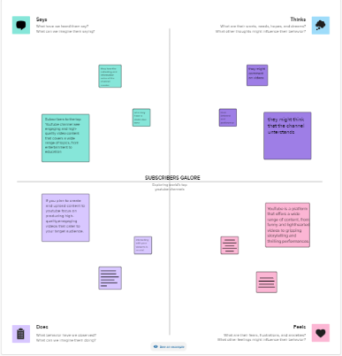

2.2.Ideation & Brainstorming map

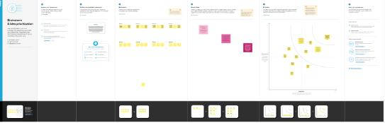

3. Result

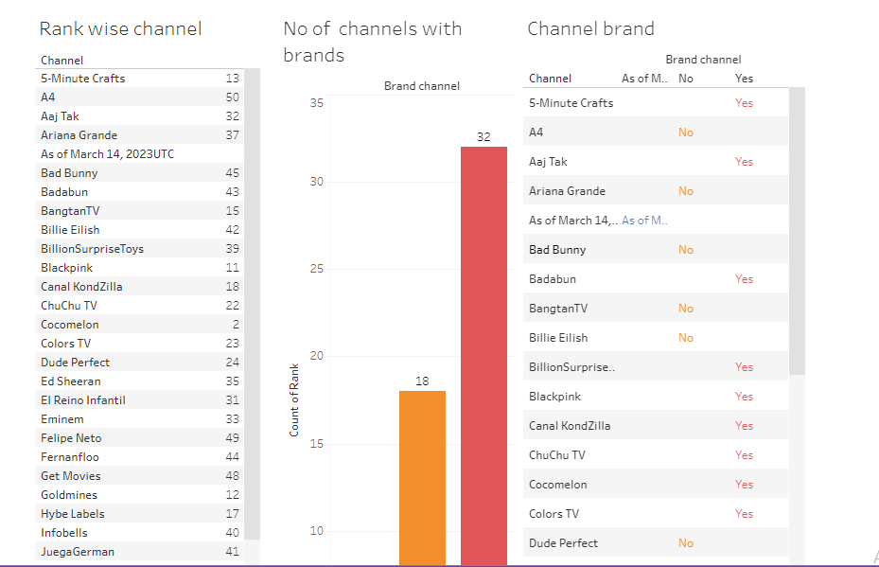

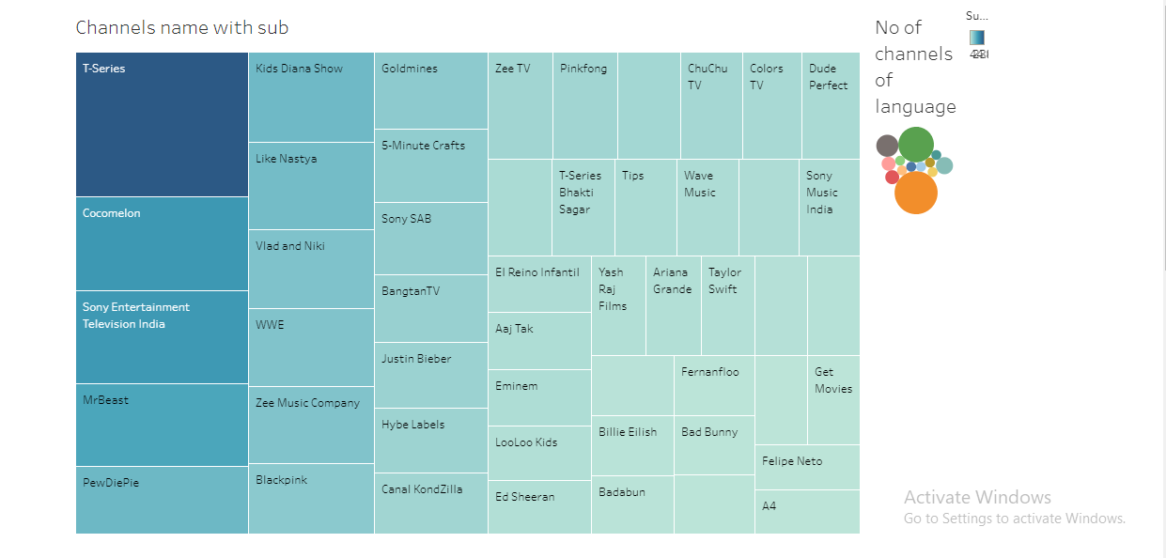

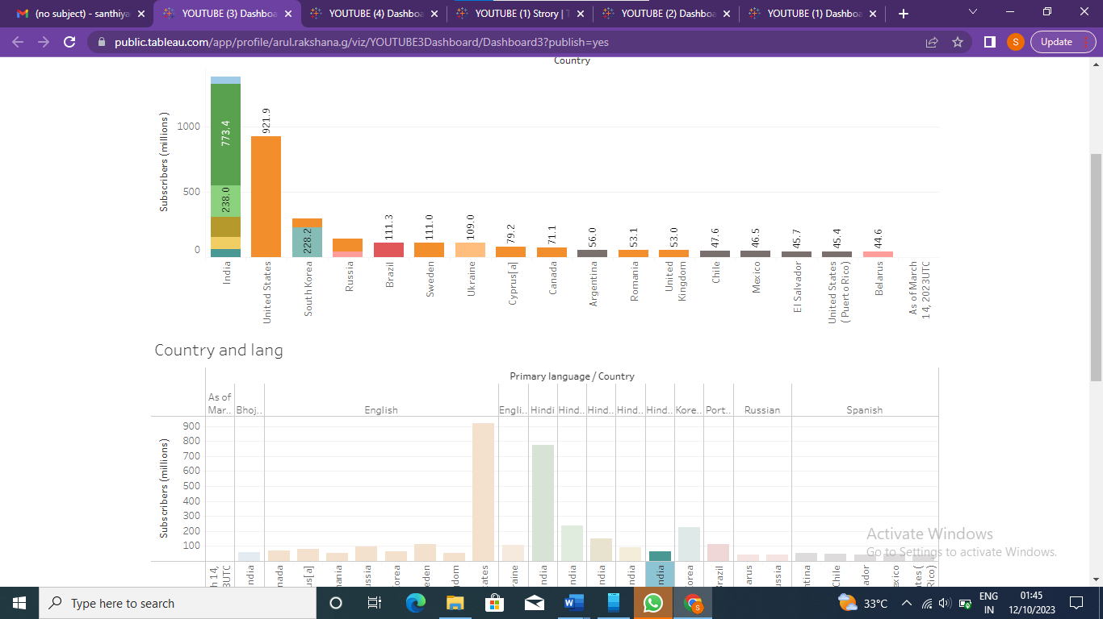

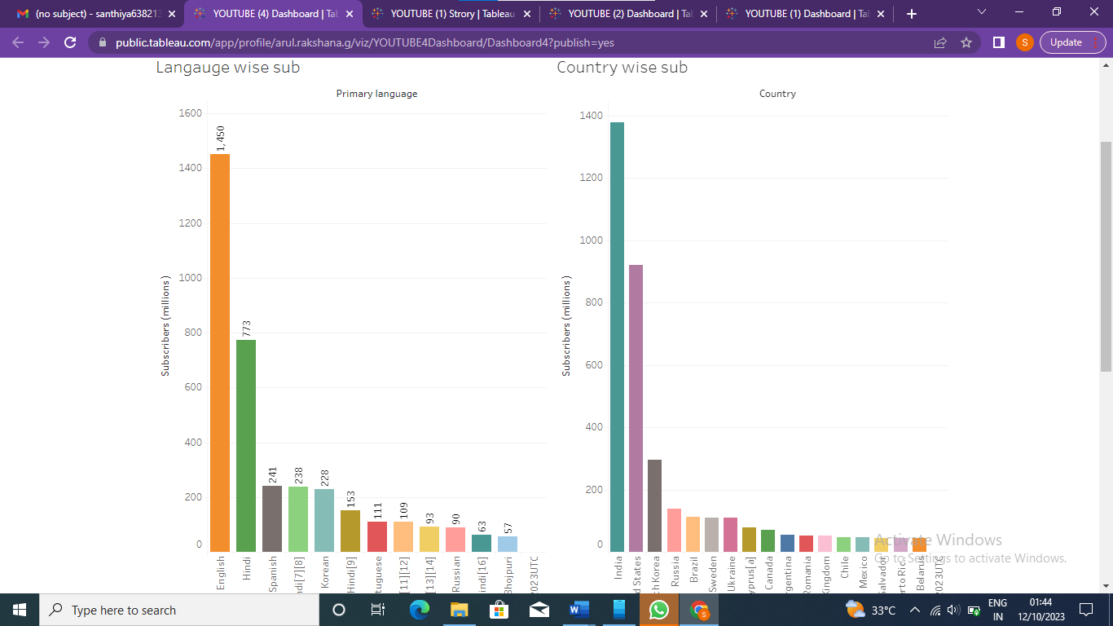

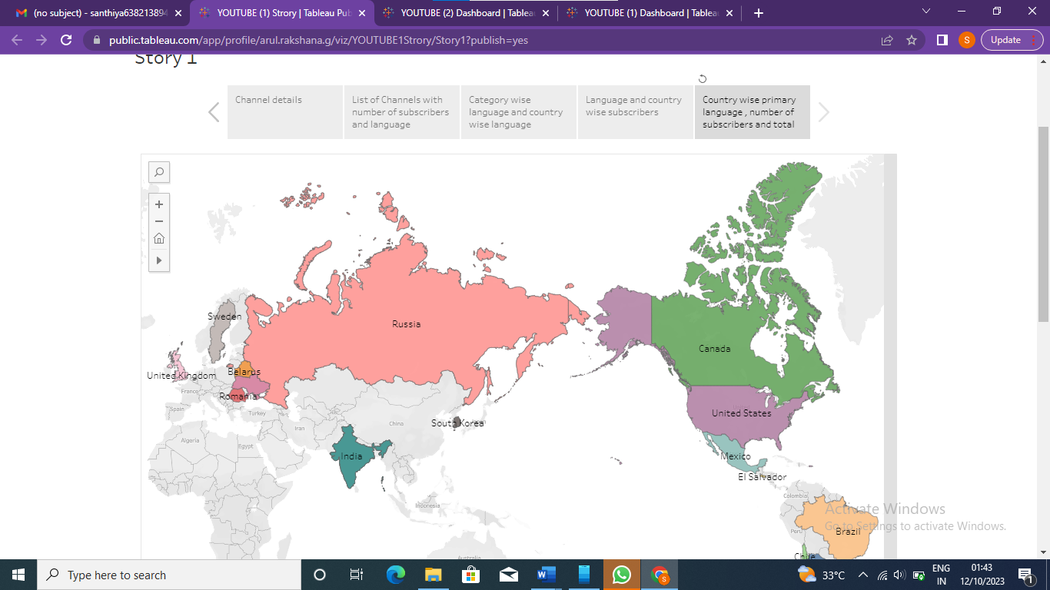

4.1 Advantages

* After parties & live chat.
* Smart device integration.
* Smart downloads.
* Co-Watch with Google Meet.
* Special offers and early access to new features.

4.2 Disadvantages

* There's inappropriate content all over the site.
* It can cause meltdowns.
* It can be addictive.
* Your child is targeted by ads, ads and more ads.
* It can affect sleep.
* YouTube comments can be problematic.

5.Applications

Create videos viewers can't stop watching.

Know your niche and stick to it.

Double down on content your audience loves.

Customize your channel to stand out.

Don't be afraid to ask for subscribers.

Keep viewers hooked with recommendations.

6.Conclusion

Subscribers are also important because YouTube will send them notifications about your new videos and feature them on their homepage, helping generate more views. Subscribers also watch twice as much video as non-subscribers, so the more subscribers you have, the more watch time your videos will collect.

7.Future scope

1. Niche Content: Specializing in a specific niche can help you stand out and attract a dedicated audience. The more unique and valuable your content is, the better your chances of gaining subscribers.

2. Quality Content: As YouTube's algorithms become more sophisticated, creating high-quality content that keeps viewers engaged is crucial. This includes good production values, interesting topics, and engaging storytelling.

3. Live Streaming: Live streams were becoming increasingly popular. Engaging with your audience in real-time can foster a strong connection and encourage subscriptions.

4. Collaborations: Partnering with other content creators can help you tap into new audiences and gain subscribers from their fan base.

5. Consistency: Regularly uploading content is important. Consistency can keep your subscribers engaged and encourage them to stick around.

6. Community Engagement: Building a community around your channel can be a powerful way to retain subscribers. Responding to comments and engaging with your audience can foster loyalty.

7. Monetization: As you gain more subscribers, you can explore various monetization options on YouTube, such as ads, sponsorships, merchandise, and memberships.

8. Diversification: Consider diversifying your online presence beyond YouTube. Utilize other social media platforms to promote your channel and connect with a wider audience.

8.Appendix

A .Source code

Python **code** using functions to search for a **YouTube** channel name and output the number of **subscribers.**